### Access Control for Project Table

## Project Overview

This project focuses on **Customizing the ServiceNow Project Table** to streamline the user experience for employees with the "Employee Management" user role. The primary objective is to **hide specific fields** from this user group to help them concentrate on their assigned responsibilities. By leveraging ServiceNow's customization capabilities, this initiative aims to **enhance operational efficiency**, **reduce distractions**, and ensure data security by restricting access to non-essential fields.

# Objectives

**Business Goals:**

* Improve the usability of the Project table for "Employee Management" users.
* Enhance data security by restricting access to sensitive fields.
* Optimize employee productivity by displaying only relevant information.

**Specific Outcomes:**

* A customized Project table view for "Employee Management" users.
* Documentation of the fields hidden and the rationale behind each.
* Validation of the solution across different use cases.

# Key Features and Concepts Utilized

This highlights the main functionalities and concepts applied within the project.

• **Role-Based Access Control (RBAC):** Restrict visibility of fields based on user roles.

• **UI Policy and Script Customization:** Implementation of ServiceNow UI policies or client scripts to hide fields dynamically.

• **Testing Frameworks:** Use ServiceNow testing tools to validate the customization.

# Detailed Steps to Solution Design

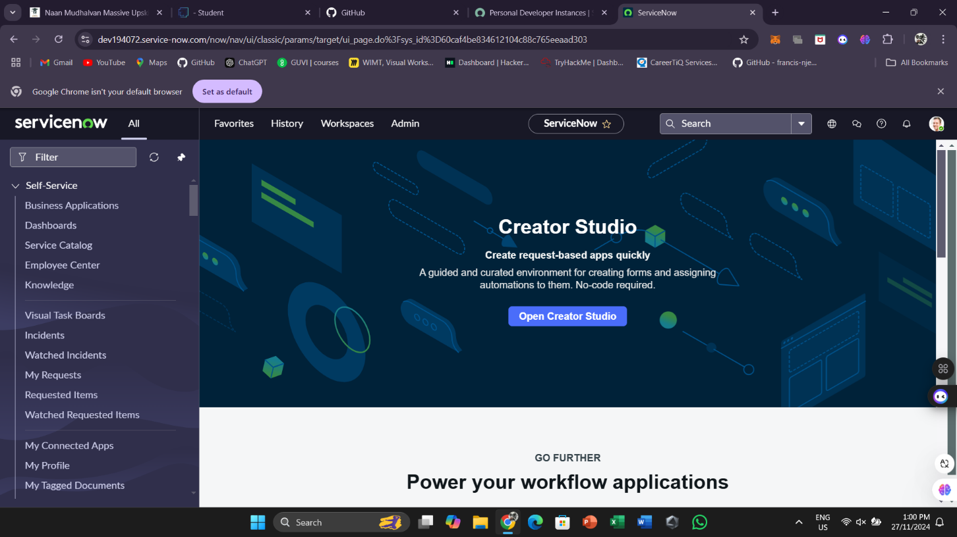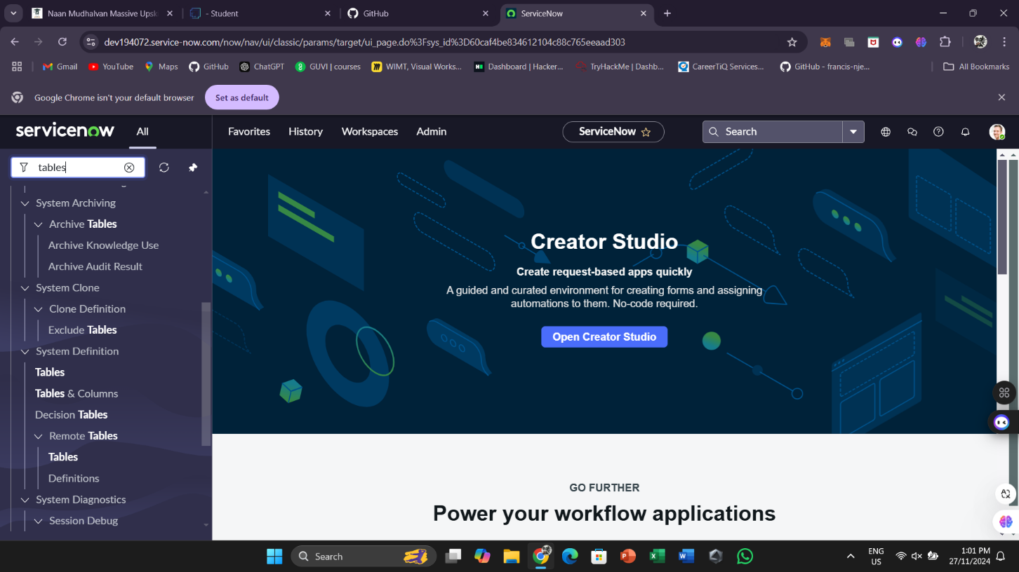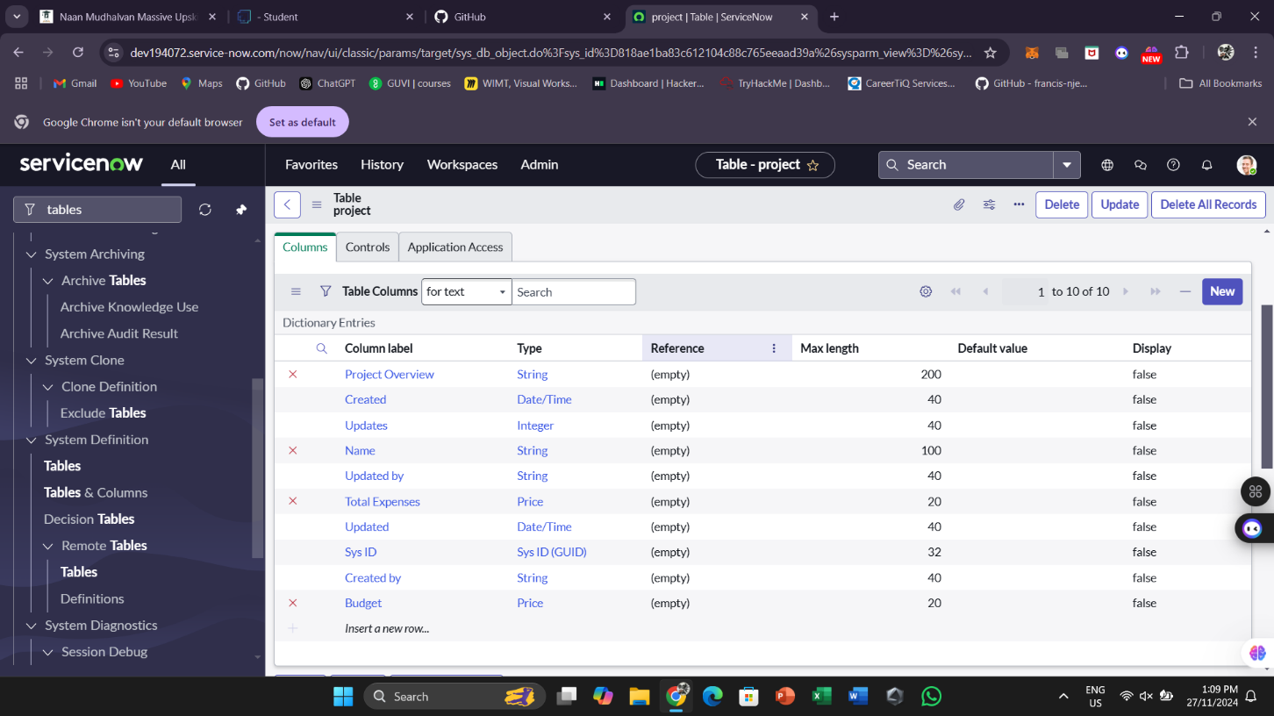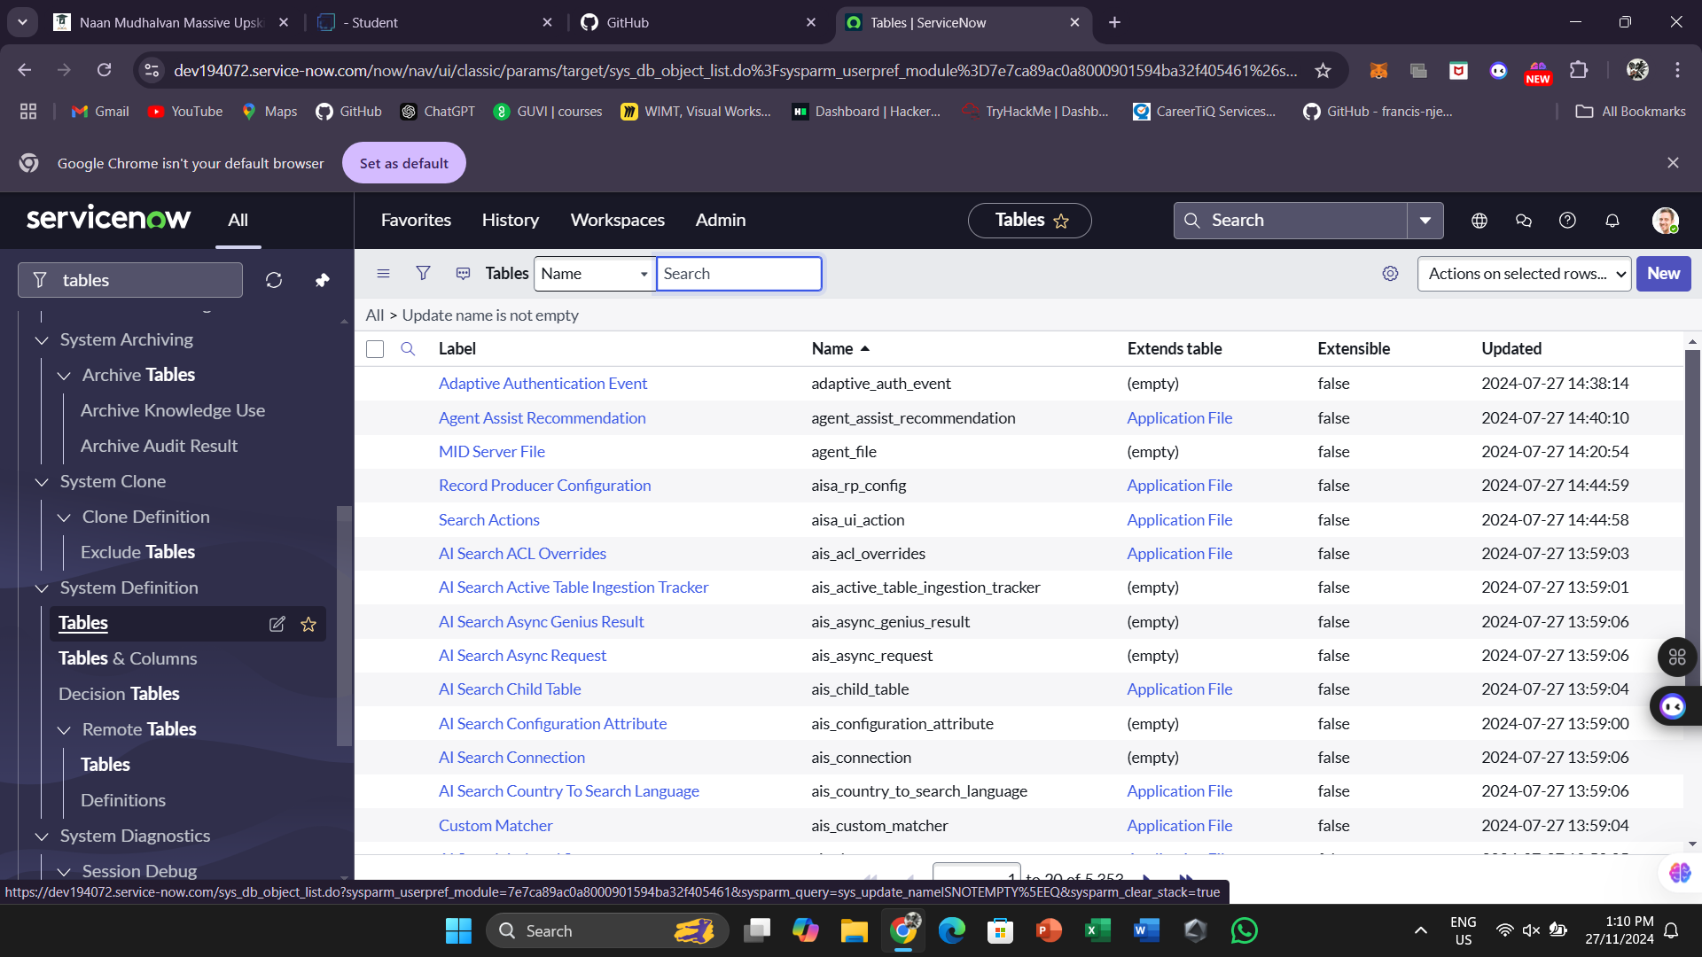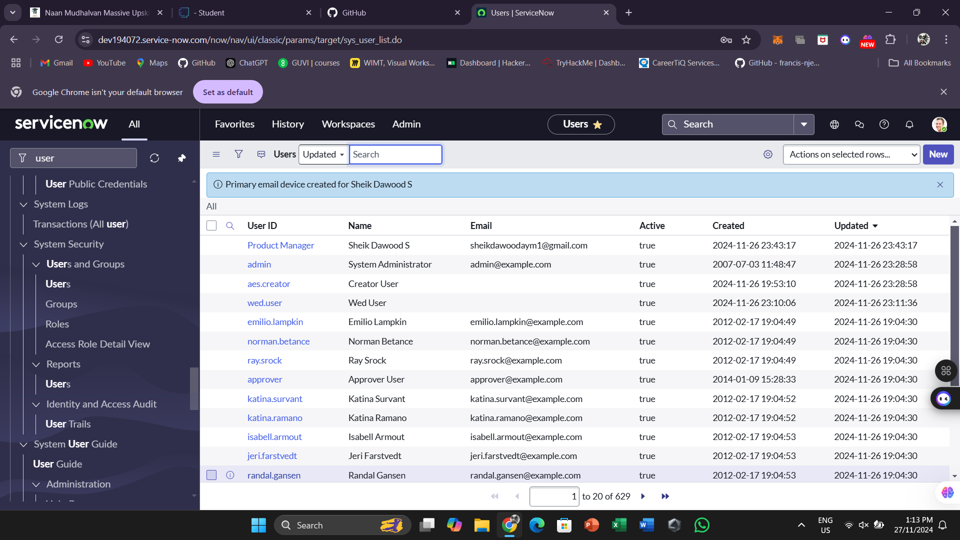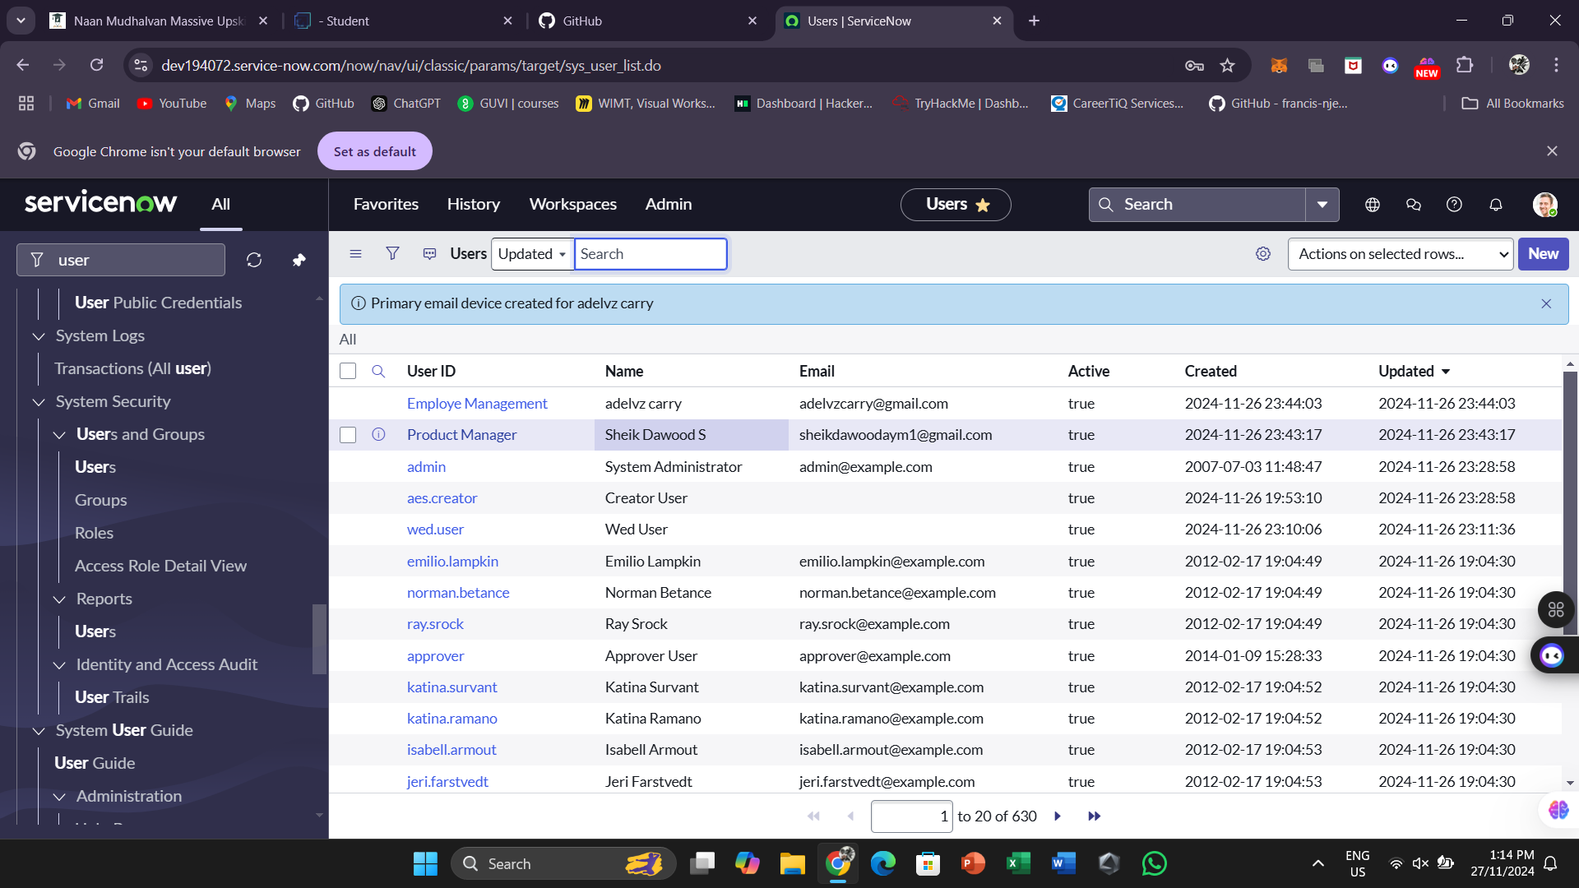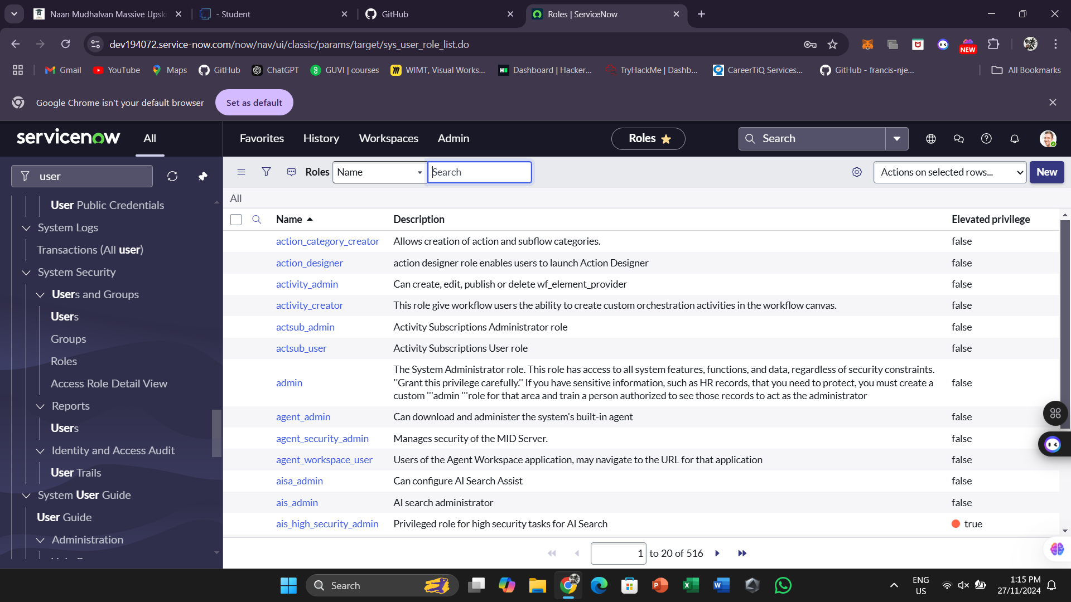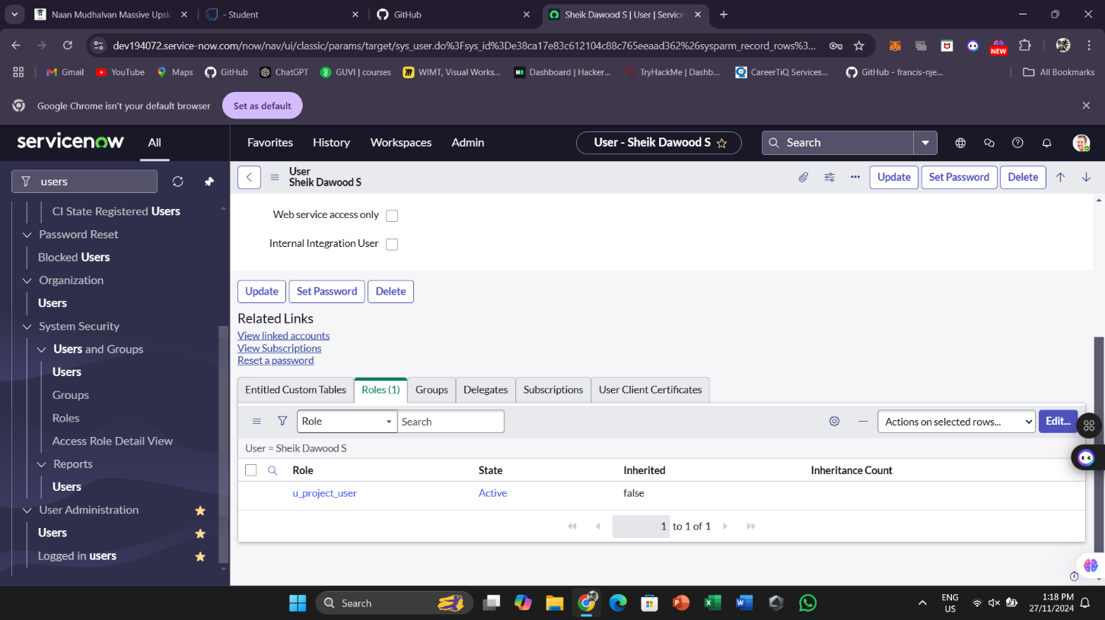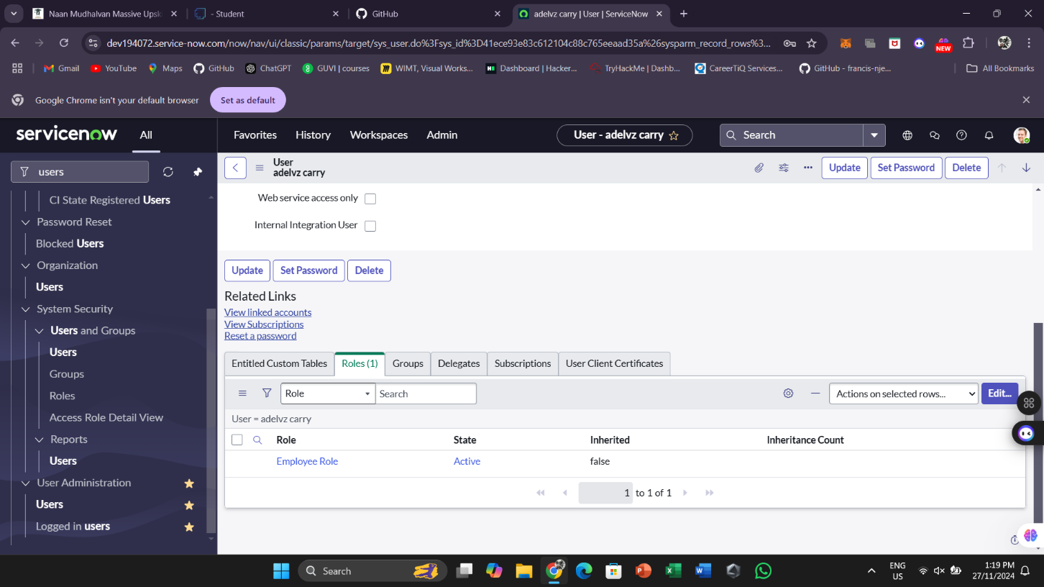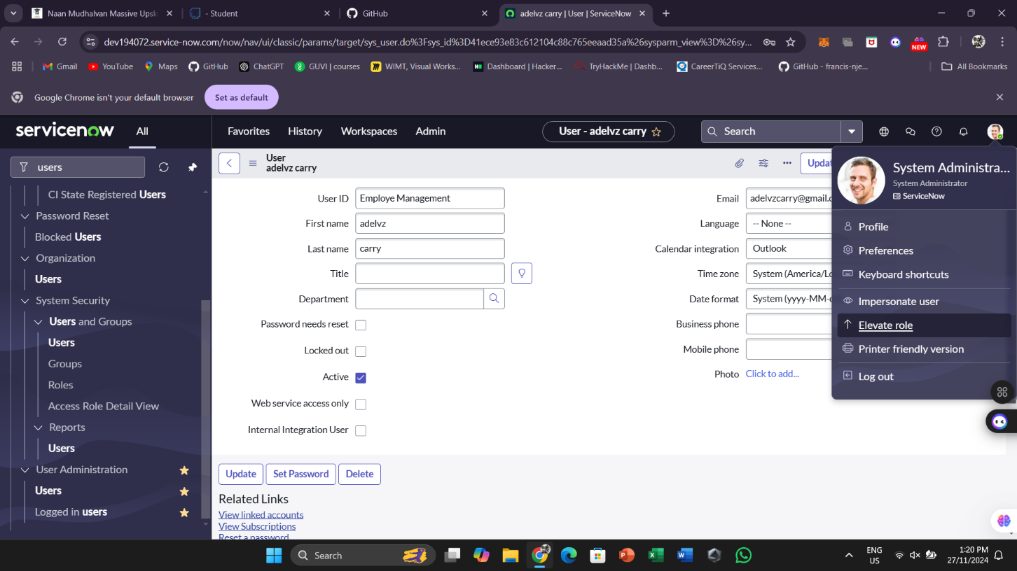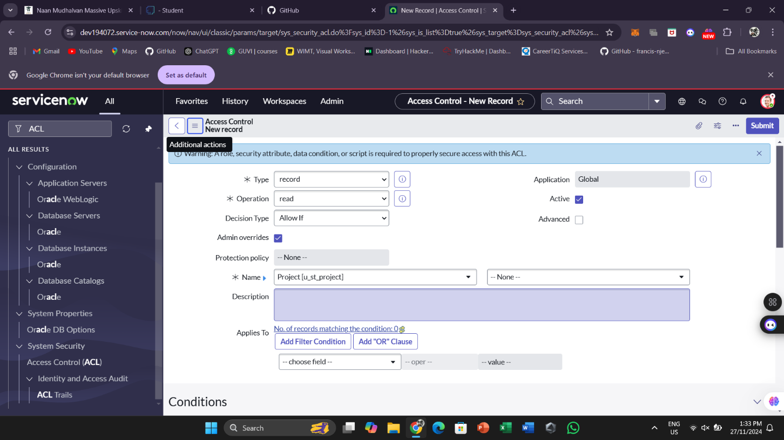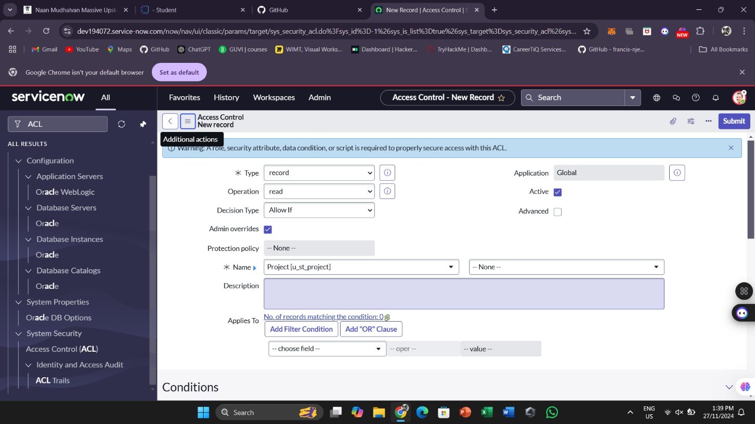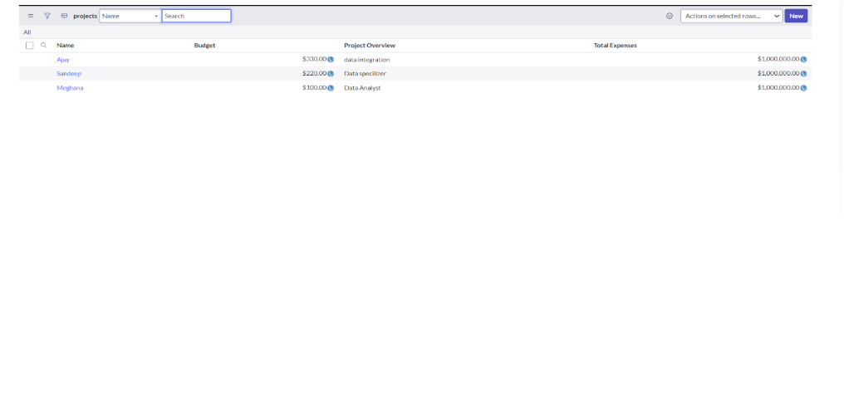

# 5.Testing and Validation

• **Unit Testing:** Verify each field's visibility rules with test users.

• **User Interface Testing:** Ensure the interface is intuitive and works as expected for all roles.

### **6. Key Scenarios Addressed by ServiceNow in the Implementation Project**

* **Scenario 1:** "Employee Management" users access the Project table and see only permitted fields.
* **Scenario 2:** Other user roles access the table with full visibility to ensure role-based access is correctly implemented.
* **Scenario 3:** Changes are tested across multiple devices and browsers for compatability

### **7. Conclusion**

**Summary of Achievements:**  
The customization successfully implemented role-specific access control on the ServiceNow Project table. This ensures that "Employee Management" users can focus on their tasks without distractions, enhancing productivity and securing sensitive information.